**INTI International College Penang School of Engineering and Technology 3+0 Bachelor of Science (Hons) in Computer Science, in collaboration with Coventry University, UK 3+0 Bachelor of Science (Hons) in Computing, in collaboration with Coventry University, UK**

**Coursework cover sheet**

**Section A - To be completed by the student**



|  |  |
| --- | --- |
| Full Name: ARSYAD HASSAN BIN SEGU HASAN GANI | |
| CU Student ID Number: P22014749 | |
| Semester: 1 | |
| Session:  **August 2022** | |
| Lecturer:  **Nadhrah Abdul Hadi (nadhrah.abdulhadi@newinti.edu.my)** | |
| Module Code and Title:  **4067CEM Software Design** | |
| Assignment No. / Title:  **Continuous Assessment** | % of Module Mark:  **50** |
| Hand out Date:  **6th September 2022** | Due Date:  **Task 1: 30 September 2022, by 11.59pm.**  **Task 2: 18 November 2022, by 11.59pm**  **Task 3: 4 November 2022, by 11.59pm.**  **Task 4: 4 November 2022, by 11.59pm.**  **Task 5: 4 November 2022, by 11.59pm.** |
| Penalties: No late work will be accepted. If you are unable to submit coursework on time due to extenuating circumstances, you may be eligible for an extension. Please consult the lecturer. | |
| Declaration: I/we the undersigned confirm that I/we have read and agree to abide by the University regulations on plagiarism and cheating and Faculty coursework policies and procedures. I/we confirm that this piece of work is my/our own. I/we consent to appropriate storage of our work for plagiarism checking.    Signature(s): ________________________ | |

**Section B - To be completed by the module leader**

|  |  |  |
| --- | --- | --- |
| Intended learning outcomes assessed by this work:  1. Understand and apply appropriate concepts, tools and techniques to each stage of the software development  2. Understand and apply design patterns to software components in developing new software  3. Demonstrate an understanding of project planning and working to agreed deadlines, along with professional, interpersonal skills and effective communication required for software production  5. Demonstrate an awareness of, and ability to apply, social, professional, legal and ethical standards as documented in relevant laws and professional codes of conduct such as that of the Malaysian National Computer Confederation. | | |
| Marking scheme | Max | Mark |
| 1. User Story Mapping 2. Setting up a GitHub Repository 3. Creating a Class diagram and design pattern selection 4. Creating a Prototype User Interface and Usability Testing 5. Discuss the ethical issue related to the software | 20  10  30  20  20 |  |
| Total | 100 |  |

**TASK 1: USER STORY MAPPING**

**Vision**

**What is the problem?**

From the survey that I conducted, I can see that many of our students are facing the main problem which is on how to communicate or be friends with other students in our college. In adddition, this also lead them to be lonely and also affect them on their teamwork skills. Students in our college needs to know other students too so that their activities in college can go smoothly without any awkwardness.

As to solve this problem, a buddy application will be designed and developed so that our college students can make use of it to make many friends. Other than that, students also can view other student’s personal interest and gain more confidence to have a chat with them. Furthermore, from the survey that I’ve done, it shows that most of my respondents are preferring to have this buddy application so that the environment of our college will turn more positive.

**Who are the users?**

The users will be the students of our college only. This is because the main aim of this application is to make our students to make many friends throughout their journey in their college life.

Survey Google Form Questions are shown below:

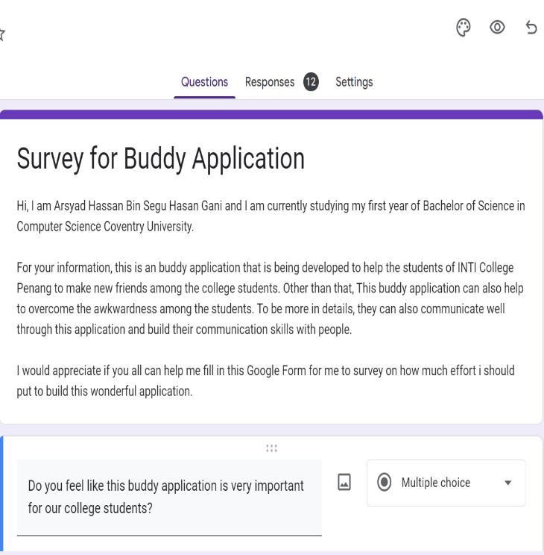

**Figure 1.1 Survey Google Form Questions**

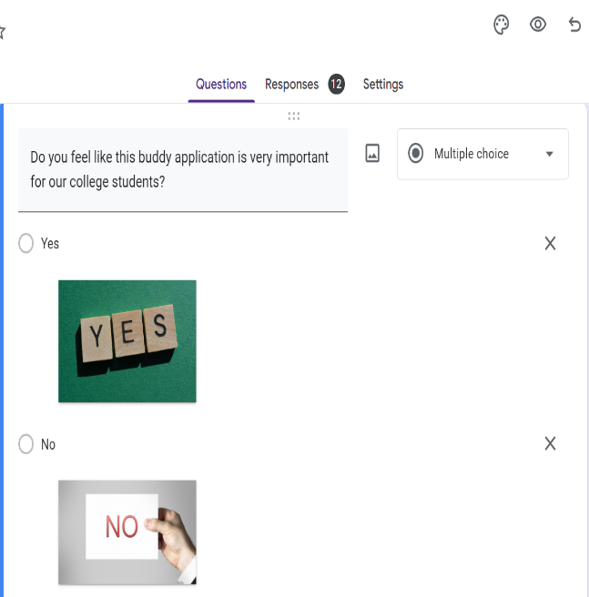

**Figure 1.2 Survey Google Form Questions**

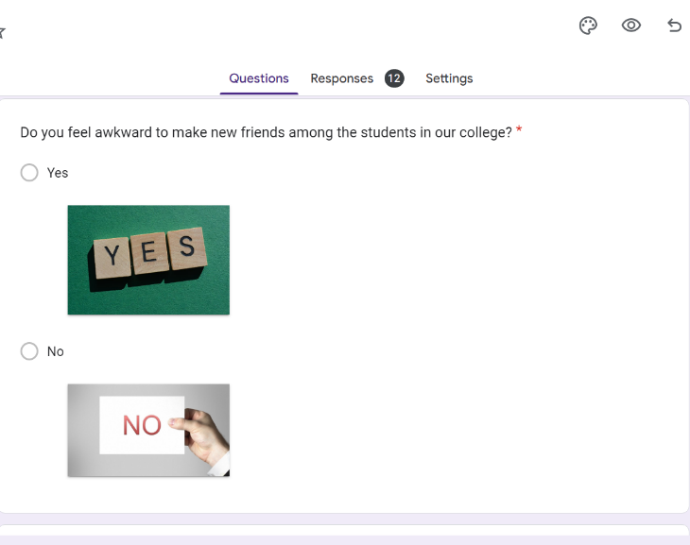

**Figure 1.3 Survey Google Form Questions**

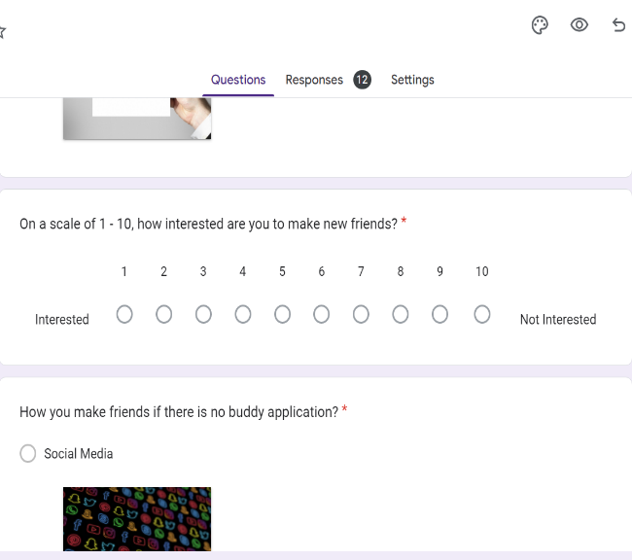

**Figure 1.4 Survey Google Form Questions**

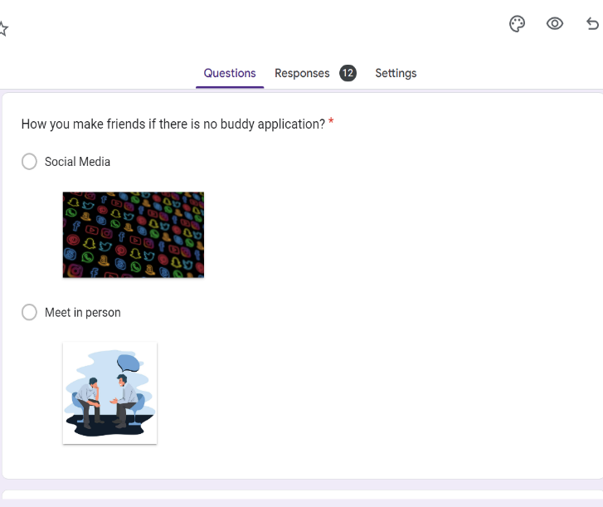

**Figure 1.5 Survey Google Form Questions**

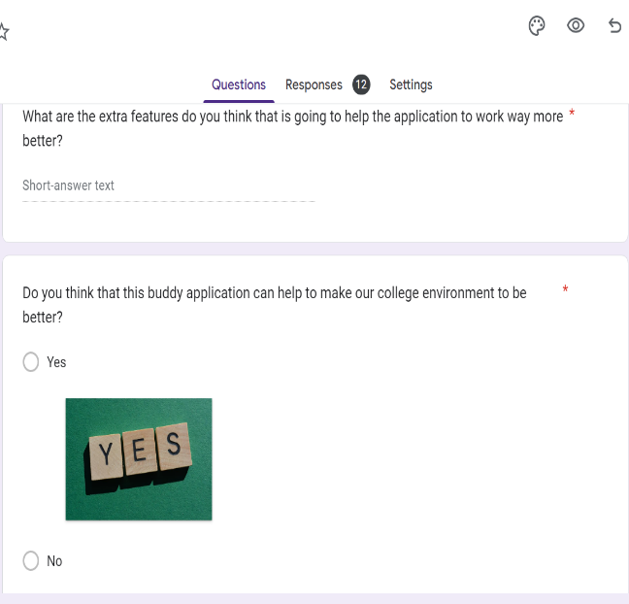

**Figure 1.6 Survey Google Form Questions**

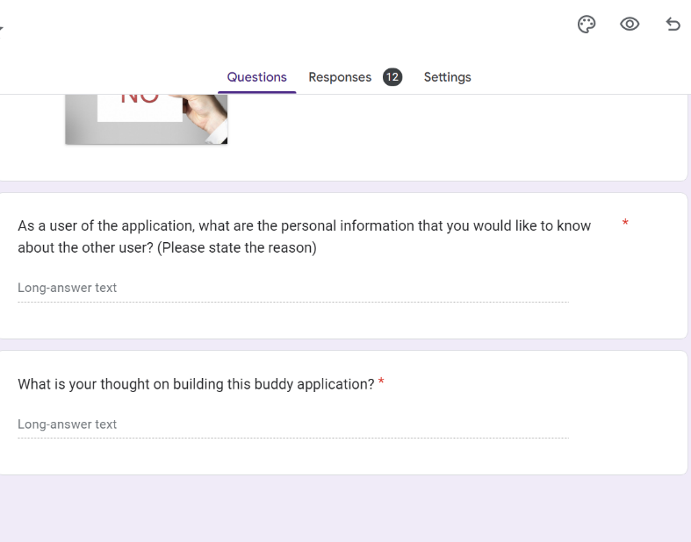

**Figure 1.7 Survey Google Form Questions**

The number of respondent and the summary of all questions are shown below:

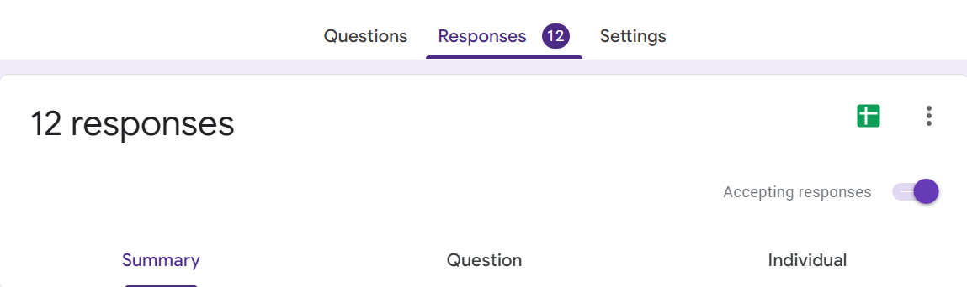

**Figure 2.1 Number of Responses**

**Question 1:**

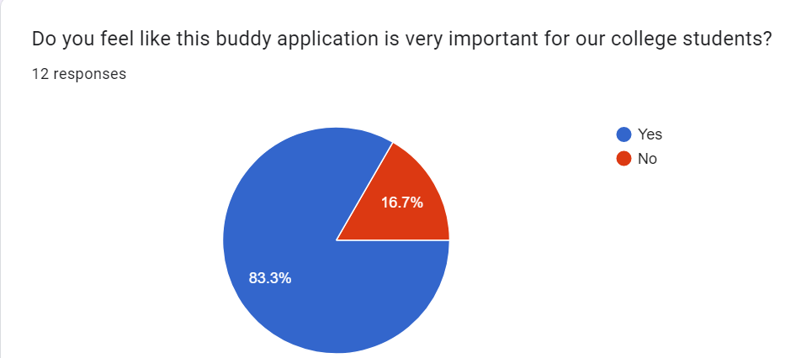

**Figure 2.2 Buddy Application Survey Responses**

Figure 2.2 shows that 83.3% of the students are saying that this buddy application is very important for our college while 16.7 of them are saying it is not important.

**Question 2:**

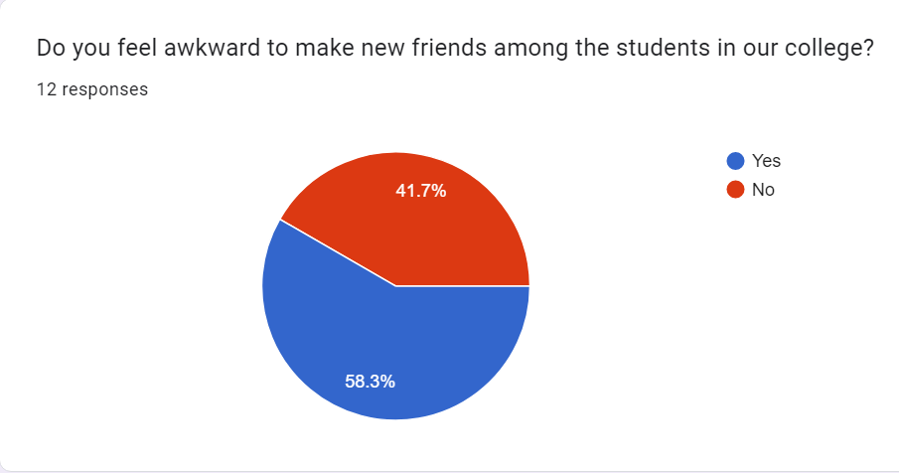

**Figure 2.3 Buddy Application Survey Responses**

Figure 2.3 shows that 58.3% of students feel awkward to make new friends among the students in our college while 41.7% of them does not feel awkward to make new friends.

**Question 3:**

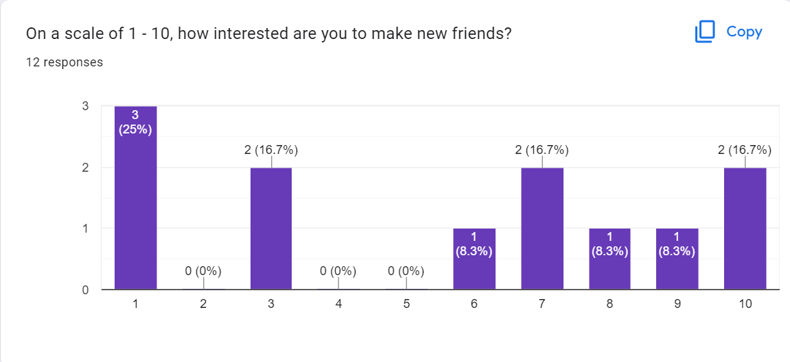

**Figure 2.4 Buddy Application Survey Responses**

Figure 2.4 shows that the scale of the interest on making new friends of the students where the highest is 16.7% chose very interested while 25% chose the lowest on not interested.

**Question 4:**

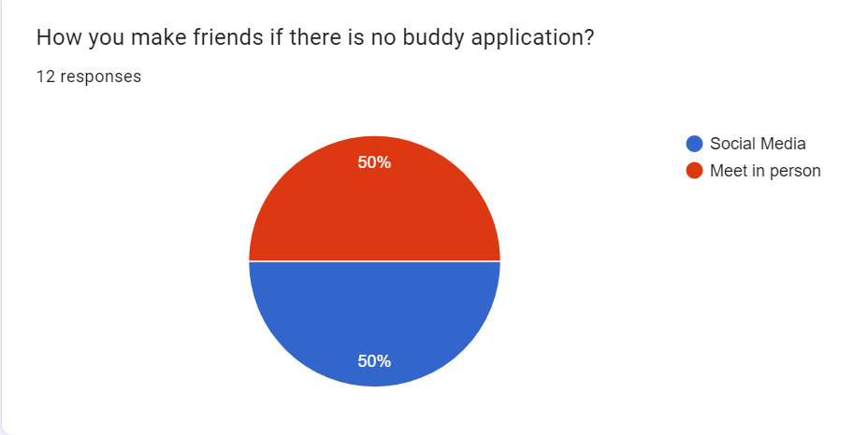

**Figure 2.5 Buddy Application Survey Responses**

Figure 2.5 shows that 50% of the students make friends through social medias while the other 50% chose to meet in person to make new friends.

**Question 5:**

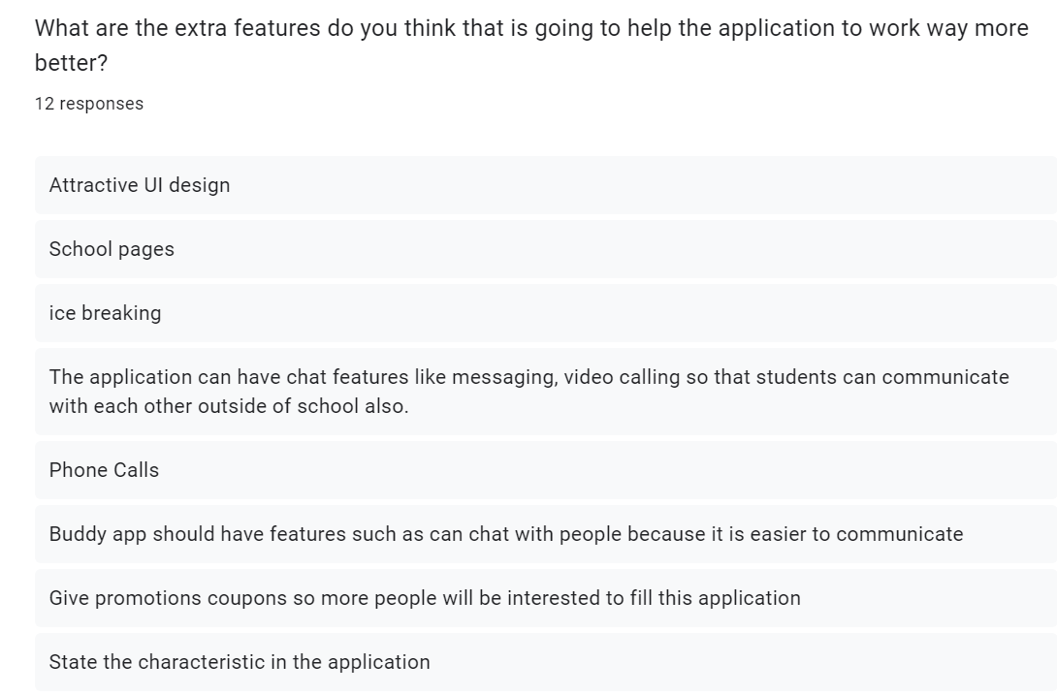

**Figure 2.6 Buddy Application Survey Responses**

Figure 2.6 shows that students chose to have ice breaking session, phone calls, messaging options, give promotion coupons and so on as the extra feature to be in the application so that the buddy application works more better.

**Question 6:**

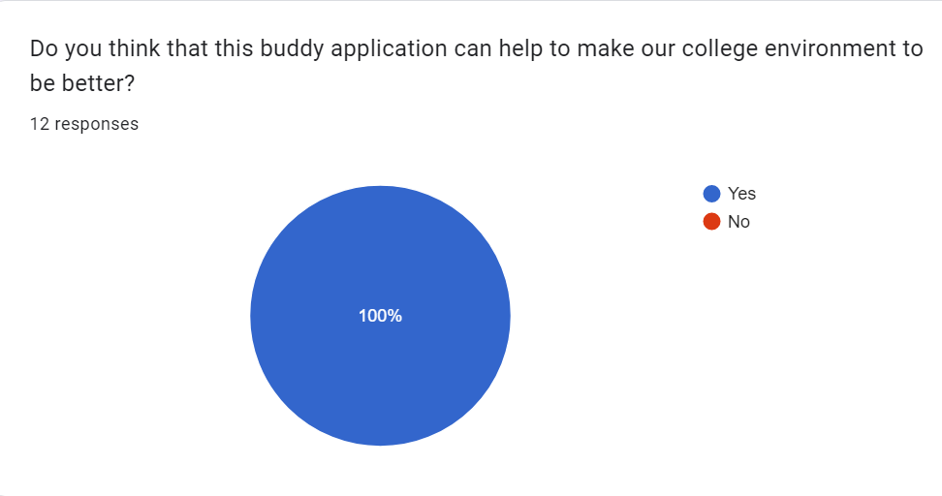

**Figure 2.7 Buddy Application Survey Responses**

Figure 2.7 shows that 100% of the students supports the aim of this application where it helps to make our college environment to be better.

**Question 7:**

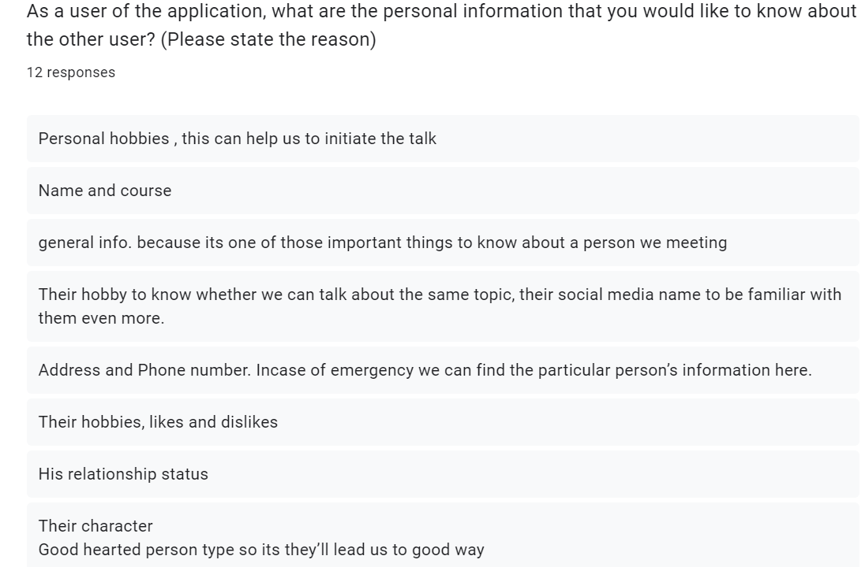

**Figure 2.8 Buddy Application Survey Responses**

Figure 2.8 show that students want to know about the personal details about the other user such as name, course, hobbies, address, phone number, relationship status, likes and dislikes, social media username and so on.

**Question 8:**

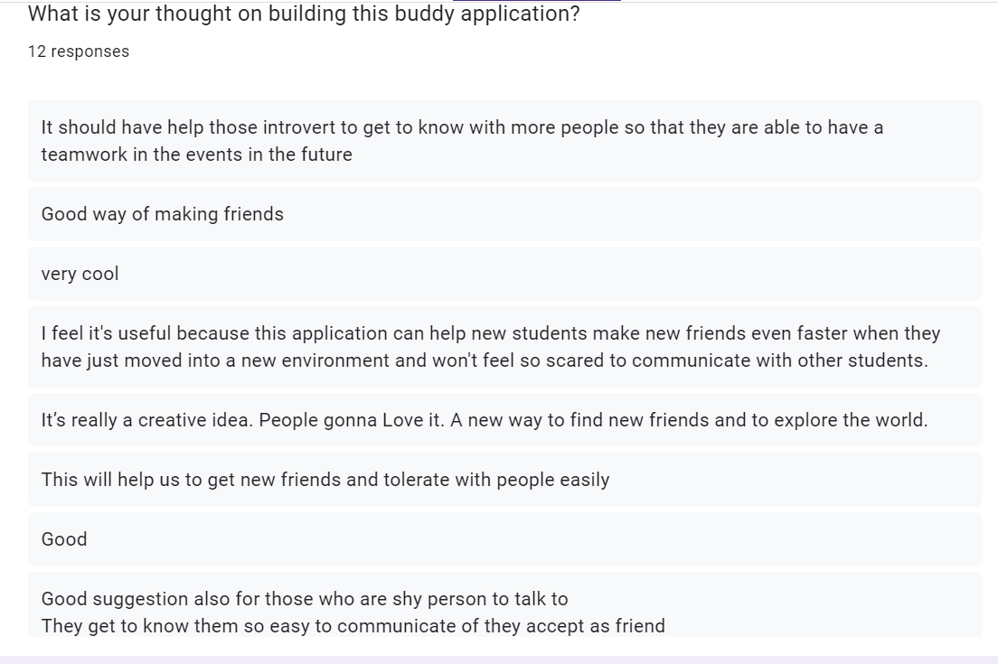

**Figure 2.9 Buddy Application Survey Responses**

Figure 2.9 shows that the thought of the students on building this application where the responses are very positive such as good, very cool, good way of making friends, helps to make many new friends and many more.

The User Story Mapping for my buddy application is shown below:

